Armed with answers to the following questions, we can ensure that everyone, including the client and the consultant who may have the work escalated up to, are all on the same page and pointing in the right direction.

1. How is the performance issue presenting itself?
2. What error messages are you receiving if any?
3. How many users are being affected by the issue?
4. How critical is this issue to the business?
5. Who can assist with the investigation from the client's side and what are their contact details?
6. Is someone else looking at the issue? If so do you have their contact details and do you know what have they done so far?
7. Is this a new or a reoccurring problem?
8. Do you know the name of the failing process?
9. What is the name of the server/application/instance?
10. Has anything changed at the database, application or infrastructure level recently?
11. Is there any additional load, i.e. monthly processing, year end, stocktake etc.?
12. Is this the only application on the SQL Server, and if not are the others experiencing performance problems?
13. Can we manually rerun the failing/slow process multiple times without affecting the underlying data?
14. Is there a test/development environment where we can reproduce the problem?

Or you can do it this way:

I’ve added a link to the performance investigation first responder questions in Connectwise to make it quick and easy to get hold of the info, should you take a performance issue support call.

Select the “1st Responder…” link at the top of the ticket page and then select the magnifying glass icon to open the question list.

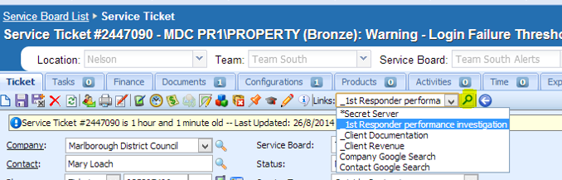

Please ask the listed questions of any client who raises a new performance investigation issue, and retain the answers for your investigation, or pass the information on the DBA/Consultant who is going to carry out the investigation.